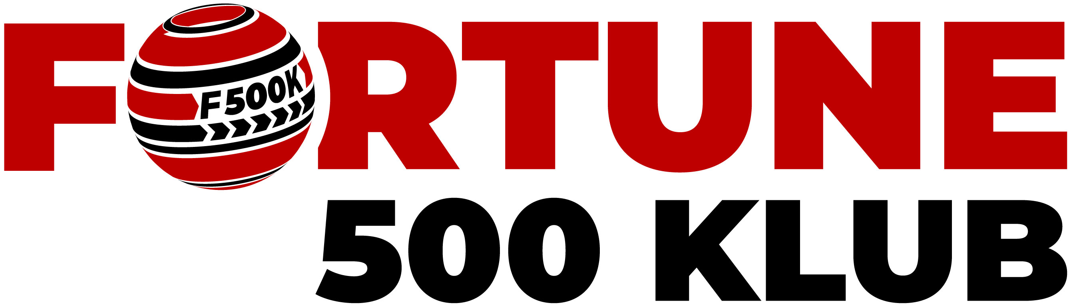 **January 1, 2025**

Dear Fortune Investors,

Special greetings to you members and your families!

It’s a great pleasure once again to be writing to you in this second letter as we reflect on our investment journey through the year 2024. When we started Fortune 500 Klub in April 2018, were driven by the desire to aggregate our funds, experiences, expertise and tested practices to harness the opportunities presented by the changing global economic and investment landscape. Our mission is to revolutionalize the investment landscape by providing a dynamic and disruptive investment platform that empowers individuals to transform their personal savings into revenue generating investments.

Since my first letter (<https://www.fortune500klub.com/storage/resources/1f95c68e8a2c.pdf>) shared with you on January 16, 2024, the global economic landscape has changed in many fundamental ways. These changes will have profound impacts on our pursuit of financial security and freedom for years to come. This will invariably have impact on the financial security and freedom of our children and those within our families and social networks.

1. **The potential arenas of the future**

One of my most inspiring readings of 2024 was the October 2024 McKinsey Global Institute (MIG) report entitled ***The next big arenas of competition***. In that report, MGI identifies 18 industries (arenas) that will transform the global business landscape. Accordingly, these industries are projected to generate some US$29 trillion to US$48 trillion in revenues by 2040. These arenas are: e-commerce I AI software & services I cloud services I electric vehicles I digital advertising I semiconductors I shared autonomous vehicles I space I cybersecurity I batteries I modular construction I streaming videos I video games I robotics I industrial & consumer biotechnology I future air mobility I drugs for obesity & related conditions I nuclear fission power plants. These arenas are considered unique because they are characterised by high growth and dynamism.

I don’t know about you members! But this landscape makes me both frightened and inspired at the same time. Frightened because I don’t feel that as Ugandans, we are acting strategically enough to be players in these domains. As these economic arenas develop, will we and our children just remain consumers of products and services in these domains? Or are we ready to step up and be players in building and producing solutions that give us presence, and where possible dominance in the regional and global marketplace?

But I am also inspired because I know that with Fortune 500 Klub, we are building a platform from where we are collectively confronting the challenges of the future. As a club, we are pulling small monies together; we are building an incredible platform that brings together the diversity of professionals and talent that is unprecedented. And yes! The power of togetherness is bringing these business possibilities and opportunities within our reach. The last 6 years of building, learning and investing have already demonstrated that our togetherness has tremendous potential to create limitless opportunities and possibilities for our future and the future of our children.

1. **What we have learnt over the last year**

As I wrote in my first letter, Fortune 500 Klub is like building the road and constructing the bridges along the way. While we may not have all the answers to many questions about our model, we have absolute clarity on the nature of success that awaits beyond the horizon – financial security delivering maximum financial freedom for each one of us achieved through the power of togetherness. The work of building the Klub and interactions with many of you members has given us several lessons that are worth pointing out for our continued reflections and learning.

* 1. **Milestones achieved during the year 2024**

We are tracking our progress milestones along a number of performance parameters. I am therefore delighted to share with you some highlights along these parameters.

1. ***Membership growth***

We have continued to grow in membership. Remember, our model is built on the power of numbers. The Club is designed as a vertically and horizontally integrated model that connects each one of us together eliminating all social, economic, partisan, geographic or gender barriers to collective investing. As of December 31, 2025, we are 1,176 members generating over UGX1.1 billion in gross investment funds and an additional over UGX700 million in Dedicated Investment Contributions.

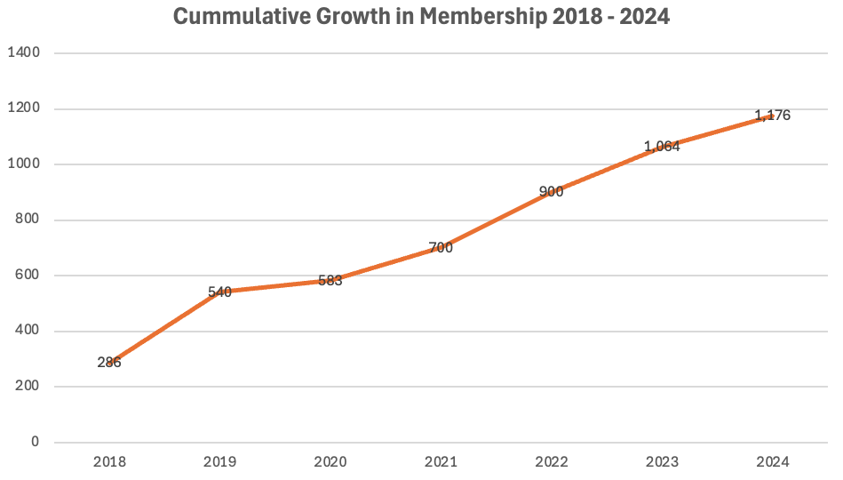

Our target is to grow to a membership of 20,000 members by 2030. The current membership provides us the foundation to hit this target before 2030. Achieving this growth target is our collective responsibility. All you need to do as a member of the Klub is to invite at least a minimum of one person within your network to join the Klub. Our digitally enabled recruitment system makes it possible for any person join the club, anytime, anywhere. Remember, every time you get a member to join, you have increased the potential to grow your personal revenues.

1. ***Investment operations***
2. Fortunetech Ltd

Over the course of the year, we completed the restructuring of the Company from a single member company (SMC). The restructuring created opportunity for members to invest directly in the Company through debt financing. The restructuring included changing the share structure of the Company resulting into the creation of 50 million shares divided into 20,000,000 ordinary shares and 30,000,000 preferential shares. We encourage members to take advantage of the current call for pre-seed financing with a minimum debt financing of UGX5,000,000 as a prequalification for buying shares in the Company. Shares of the Company are being offered at a nominal price of the Company is UShs1 until the end of the pre-seed financing round. Fortune 500 Klub invests on behalf of all the members in these special purpose investment vehicles.

In October 2024, the Company embarked on developing its first Minimum Viable Product (MVP). A Pan-African team of engineers led by Mr. Duncan Asiimwe and comprising of members from Uganda, Eritrea, Ethiopia and Morrocco is currently working on the product with a launch date of March 31, 2025. The Company is currently raising UGX250 million in pre-seed financing (<https://www.fortune500klub.com/storage/resources/57014935cd75.pdf>) towards the cost of developing the MVP. There are only 50 slots for Klub members who wish to invest directly in the Company by acquiring shares. The slots are offered on a first-come-first-served basis.

I invite you members to appreciate the leadership of our board chairman for Fortuntech Ltd Richard Ssewakiryanga and all the board members: Samantha Mwesigye (BP17-00703), Peace Nganwa (Bp17-00668), Frank Tumusiime (BP24-01045) and Hashim Mulangwa (BP16-00624) for spearheading the start-up operations of the Company.

1. Fortune Real Estates Ltd

Fortune Real Estates Ltd held its first Annual General Meeting (AGM) in 2024. The Company shareholders reached 73 members. This leaves 23 slots to reach a membership target of 100 shareholders. By the end of 2024, the Klub had invested approximately UGX600 million while an additional UGX420 million was invested by the 73 shareholders in form of Dedicated Investment Contributions (DICs). The Board also decided to put the land comprised in Fortuneville 1 on sale at a price of UGX40 million for 50X100ft plots.

We are grateful to the Board Chairman Joan Larok(BP18-00732) and Board members: Olyvia Nakitto Tibayeita (BP13-00503), Gerald Barekye (AD1-00143), Jackie Okao (BP19-00775), Timothy Gaburungi (BP21-00938) and Michael Woira (BP1-00001) for their continued stewardship of the Company.

1. Fortune Financial Services

Fortune Financial Services continued to offer money lending services to our members and the public. The company has shown incredible potential to generate high revenues. However, the envisaged investment in terms of operating capital was not realized as a result of the slowdown in the investment funds flow from members.

Over the course of 2025, we will work on restructuring the Company to give the Board flexibility to attract direct investments from members and other potential investors. Upon completion of the restructuring process, a new Board will be appointed to steer the Company. We are very grateful to the Board Chairman Richard Baguma (BP1-00019) for steering and overseeing the growth of the Company.

* 1. **Where did we fall short of our commitments?**

***Investment versus savings*** – this has probably been the most challenging lesson for us as your club admins. Fortune 500 Klub is conceived as an investment club as opposed to the traditional savings clubs. Part of the reason we adopted the “wallet-friendly” principal was to encourage members to make these ‘small’ monthly investments hence giving them opportunity to continue participating in the traditional savings schemes. The idea is that members should instead access their revenues while the funds on their investment portfolios are invested in vehicles that generate revenues. Over the course of the year, we have had to adjust the rules to deal with our members faced with financial situations and hence request to drawdowns on their investment portfolios. Going forward, we realize that we will need to educate ourselves more about the difference between investment and savings.

***Enabling real-time access to revenues*** – one of our priorities was to fast-track access to revenues by members. We did not deliver on this commitment as we realized that our technology infrastructure had not progressed enough to meet the regulatory requirements needed to achieve this target. With the progress that Fortunetech is making towards the launch of our first Minimum Viable Product (MVP), this target is well within reach. We are therefore recommitting to you that this will be a priority deliverable in 2025.

***Regular communication between members and Club admins*** – I am conscious that our communication with you the members has not been the best. During our start-up operations, we relied heavily on communicating via WhatsApp. As the Klub has grown both in membership and investment operations, we have realized the need to communicate more in real time and using multiple channels – both digital and analogue. In 2025, we are fast reconfiguring our technology and administrative infrastructure to communicate better and serve you better.

***Slowdown in monthly investment compliance*** – during 2024, we experienced unprecedented slowdown in investment compliance. As of December 31, 2024, the funds held by members in investment arrears are approximately UGX2.1 billion.

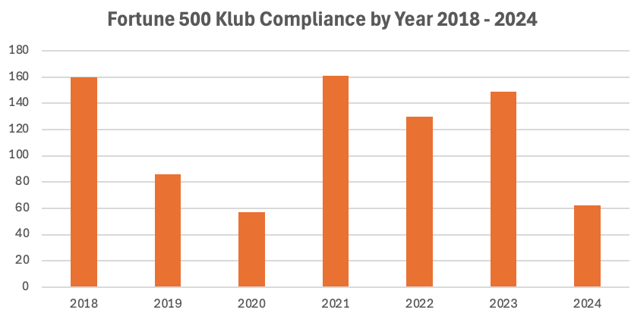

This significantly affected the way we do business, affected our planned investment operations and therefore impacted on our projected revenue flows to members. We would like to learn from you members what we can do to inspire you to take robust action in compliance to bring these arrears down so that we can channel all these funds into investment operations.

1. **Institutional Governance and Regulatory Compliance**

Part of our commitment for 2024 was to embark on the process of building the governance structures of the Club, undertake a compressive audit of Club operations and its vehicles for the period 2018-2023 and engage a financial analyst to advise on financial reporting and valuation of the Club.

Over the course of the year, the audit process was undertaken and completed by Dickson Associates and the reports for all the years have been submitted for review by the Trustees. In additional, a financial analyst was retained to undertake a comprehensive analysis and valuation of the Club covering financial and technology assets of the Club. This assignment is expected to be completed by the end of January and the basic financial reports shared with members via the Club digital platforms.

Over the course of 2025, our target is to retain an organizational development practitioner to advise on the appropriate governance structure of the Klub and the interactions of those structure with the Special Purpose Investment Vehicles. At the core of these organizational development reforms is the desire to ensure that the core principles upon which Fortune 500 Klub is built - wallet friendly investment model; inclusiveness and the unyielding pursuit of financial security and financial freedom – that continue to engender our growth and innovativeness.

1. **What to look out for in 2025**

The Fortune 500 Klub is our vehicle to venture in investments that are at the frontiers of the global economy. Our venturing into the tech economy is transformative in many ways as it will revolutionize the way we do our klub business, provide cutting-edge solutions for the management of Collective Investment Groups (CIGs) while ushering us into one of the fastest growing and lucrative sectors of the global economy. As we build the Klub governance, financial and technology infrastructure here at home, will be expanding our footprint in potential strategic markets on the continent.

As a Klub, we will position ourselves to play big in the African tech market. The macro headwinds point to the African market as both virgin and expanding at the same time. Africa has a population of approximately1.4 billion people with an average age of 19 years. An estimated 150 million people of African descent live in the diaspora and are powering some of the transformation initiatives on the continent. Diaspora Africans are providing financing in a variety of economic sectors including: real estate, agriculture, energy, technology, mining, etc. The Klub will design its technology infrastructure to facilitate greater participation of the African diaspora in Africa’s investment ecosystem.

In October 2024, the Klub secured approval of the UNAA Executive Committee to be the convener of the Trade, Investment Forum at the August 2025 UNAA Convention in New Orleans, Louisiana, United States. We have an opportunity to work with UNAA Excom, to transform the Forum into the most exciting and result oriented gathering of public sector agencies, private sector and entrepreneurs active in the trade, investment and technology business ecosystem. We will be sharing more information on how individuals Klub members can participate.

We are on fast track to launch our first MVP for Fortunetech. We therefore pledge to you once again that we should be able to resolve the challenge of real-time access to the revenues being generated and posted on your accounts. In addition, we will work with the Fortunetech board of directors to accelerate transactions on Fortuneville1 in order to increase company liquidity and pursue further real estate investments.

On the organizational development front, by the end of the first quarter of the year, we will publish macro-level analytics from the financial review in order to give you a more in-depth understanding of our Klub financial operations. We consider the work that has been done to date to provide us a credible baseline upon which future real time reporting will be based.

The Fortune 500 Klub is built on the well proven concept of the power of numbers. With numbers, we will exponentially grow our investment funds, we increase the concentration of our professional diversity, we expand our network capabilities, and we expand opportunity for each one of us.

1. **Call to Action**

There are 3 basic ways in which your membership can add value to the Club: i) make your monthly investment regular and consistent; 2) invite friends within your network to join and start investing via the Klub; and iii) offer yourself to participate on the boards and other activities of the Klub.

*"How many millionaires do you know who have become wealthy by investing in savings accounts? I rest my case."* — Robert G. Allen

Cheers to a prosperous 2025!

Godber Tumushabe

Chairman

Fortune 500 Klub

Kampala, Uganda

**©Fortune 500 Klub**

**Visit and follow us at:**

**Website:** [**https://fortune500klub.com**](https://fortune500klub.com) **Facebook: Fortune 500 Klub  
Twitter (X): @Fortune500klub  
Instagram: @fortune_500_klub**